Types of Antonyms
# Source: AI Source: Provided by: [Data Path: Persons Table -> ID Column: 1, Name_En Column: Motasem Essam] -> From: [Chatgpt (GPT-4-turbo)] on [7/30/2025]
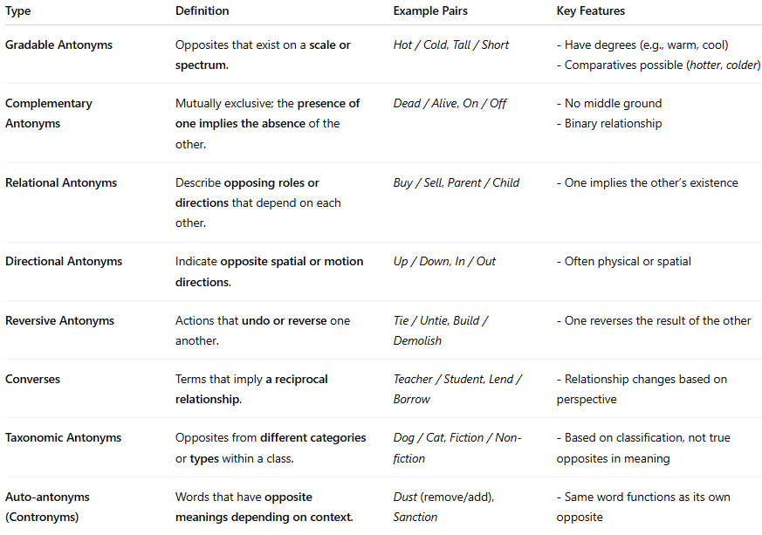

Type | Definition | Example Pairs | Key Features
Gradable Antonyms | Opposites that exist on a scale or spectrum. | Hot / Cold, Tall / Short | - Have degrees (e.g., warm, cool) - Comparatives possible (hotter, colder)
Complementary Antonyms | Mutually exclusive; the presence of one implies the absence of the other. | Dead / Alive, On / Off | - No middle ground - Binary relationship
Relational Antonyms | Describe opposing roles or directions that depend on each other. | Buy / Sell, Parent / Child | - One implies the other’s existence
Directional Antonyms | Indicate opposite spatial or motion directions. | Up / Down, In / Out | - Often physical or spatial
Reversive Antonyms | Actions that undo or reverse one another. | Tie / Untie, Build / Demolish | - One reverses the result of the other
Converses | Terms that imply a reciprocal relationship. | Teacher / Student, Lend / Borrow | - Relationship changes based on perspective
Taxonomic Antonyms | Opposites from different categories or types within a class. | Dog / Cat, Fiction / Non-fiction | - Based on classification, not true opposites in meaning
Auto-antonyms (Contronyms) | Words that have opposite meanings depending on context. | Dust (remove/add), Sanction | - Same word functions as its own opposite

